Name | Shivam gupta
Roll no | 24204B0001
Batch | 01
Subject name | Python Programming & Data Structure
Teacher Name | Ms. Rasika Patil

Experiments | 4
Title | *Develop python program to perform following operations on List:  a) Create  b) Access  c) Update  d) Delete elements from list
Practical significance
Lists in Python are crucial for storing and managing ordered collections of items, providing flexibility with various data types. They support dynamic sizing, allowing for efficient addition and removal of elements. Lists are integral to data processing tasks such as sorting, filtering, and iterating over elements. Their versatility and built-in methods enhance code readability and efficiency in handling complex data operations.
- Creating Lists:
You can create a list by simply enclosing items within square brackets. Items can be of any data type, including integers, floats, strings, or even other lists.
my_list = [1, 2, 3, 4, 5]
mixed_list = [1, "apple", 3.14, True]
nested_list = [[1, 2], [3, 4], [5, 6]] empty_list = []

- Accessing Elements:
You can access elements of a list using indexing. Indexing starts from 0 for the first element and goes up to len(list) - 1 for the last element.
my_list = [10, 20, 30, 40, 50]
print(my_list[0]) # Output: 10 (Accessing first element)
print(my_list[-1]) # Output: 50 (Accessing last element using negative indexing)

- Slicing Lists:
You can also access a portion of a list using slicing. Slicing allows you to create a new list containing a subset of the original list.
my_list = [10, 20, 30, 40, 50]
print(my_list[1:4]) # Output: [20, 30, 40] (Slice from index 1 to 3)
print(my_list[:3]) # Output: [10, 20, 30] (Slice from start to index 2)
print(my_list[2:]) # Output: [30, 40, 50] (Slice from index 2 to end)

- Modifying Lists:
Lists are mutable, meaning you can change the elements after creating the list. You can modify elements, append new elements, insert elements, or remove elements.
my_list = [10, 20, 30, 40, 50]
my_list[1] = 25 # Modify element at index 1 my_list. append(60) # Append 60 to the end of the list my_list.insert(2, 35) # Insert 35 at index 2 my_list.remove(40) # Remove the element 40 del my_list[0] # Delete element at index 0 5.

List Operations:
Lists support various operations such as concatenation (+), repetition (*), and checking membership (in).
list1 = [1, 2, 3] list2 = [4, 5, 6]
concatenated_list = list1 + list2 # Concatenate lists repeated_list = list1 * 3 # Repeat list 3 times
is_present = 2 in list1 # Check if 2 is present in list1 (returns True)

6. List Methods:
Python provides built-in methods to perform common operations on lists, such as sorting, reversing, counting, and finding elements.
my_list = [4, 2, 1, 3] my_list.sort() # Sort the list in ascending order my_list.reverse() # Reverse the elements of the list
count_1 = my_list.count(1) # Count occurrences of 1 in the list i ndex_3 = my_list.index(3) # Get index of first occurrence of

3 7. Nested Lists:
Lists can contain other lists as elements, enabling you to create nested data structures for more complex data representations.
matrix = [[1, 2, 3], [4, 5, 6], [7, 8, 9]]
print(matrix[1][2]) # Output: 6 (Accessing element in row 1, column 2)
Lists are versatile data structures in Python that play a vital role in various programming tasks,
including data processing, manipulation, and storage. Their flexibility and wide range of built-in operations make them indispensable for many programming tasks.

Programming Questions with Answer
1 | Student Management Web App – Programming Problem Statement  Design and implement a Student Management Web App (or menu-driven program) that allows an administrator to manage and analyze student marks using a list data structure.  The system should provide the following functionalities:  - Allow the admin to enter student marks and store them in a list.  - Display all student marks stored in the system.  - Calculate and display the total marks and average marks of students.  - Identify and display the highest and lowest marks in the class.  - Determine and display passed and failed students based on pass marks (≥ 40).  - Display a list of students who have scored distinction (≥ 75).  - Remove duplicate student records from the marks list.  - Replace all failed student marks with grace marks (40).  - Provide a search option to check whether a particular student’s mark exists in the system.  - Sort student marks in ascending order and also display the list in reverse order.  - Allow removal of a student record when a student leaves the course.  - Find and display the position (index/roll number) of a student based on their marks.
SCRIPT | marks = []  def enter_marks():  n = int(input("Enter number of students: "))  for i in range(n):  m = int(input(f"Enter marks for student {i + 1}: "))  marks.append(m)  def display_marks():  print("Student Marks:", marks)  def total_and_average():  if not marks:  print("No marks entered.")  return  total = sum(marks)  avg = total / len(marks)  print("Total Marks:", total)  print("Average Marks:", avg)  def highest_and_lowest():  if not marks:  print("No marks entered.")  return  print("Highest Marks:", max(marks))  print("Lowest Marks:", min(marks))  def pass_fail():  passed = [m for m in marks if m >= 40]  failed = [m for m in marks if m < 40]  print("Passed Students:", passed)  print("Failed Students:", failed)  def distinction():  dist = [m for m in marks if m >= 75]  print("Distinction Students:", dist)  def remove_duplicates():  global marks  marks = list(set(marks))  print("Duplicates removed:", marks)  def grace_marks():  for i in range(len(marks)):  if marks[i] < 40:  marks[i] = 40  print("Grace marks applied:", marks)  def search_mark():  s = int(input("Enter mark to search: "))  if s in marks:  print("Mark exists in the system.")  else:  print("Mark not found.")  def sort_marks():  marks.sort()  print("Sorted Marks:", marks)  print("Reverse Order:", marks[::-1])  def remove_student():  r = int(input("Enter mark to remove: "))  if r in marks:  marks.remove(r)  print("Student record removed.")  else:  print("Mark not found.")  def find_position():  p = int(input("Enter mark to find position: "))  if p in marks:  print("Position (Index):", marks.index(p))  else:  print("Mark not found.")  while True:  print("\n--- Student Management Menu ---")  print("1. Enter Student Marks")  print("2. Display Marks")  print("3. Total and Average Marks")  print("4. Highest and Lowest Marks")  print("5. Passed and Failed Students")  print("6. Distinction Students")  print("7. Remove Duplicate Records")  print("8. Replace Failed Marks with Grace Marks")  print("9. Search Student Mark")  print("10. Sort and Reverse Marks")  print("11. Remove Student Record")  print("12. Find Student Position")  print("13. Exit")  choice = int(input("Enter your choice: "))  if choice == 1:  enter_marks()  elif choice == 2:  display_marks()  elif choice == 3:  total_and_average()  elif choice == 4:  highest_and_lowest()  elif choice == 5:  pass_fail()  elif choice == 6:  distinction()  elif choice == 7:  remove_duplicates()  elif choice == 8:  grace_marks()  elif choice == 9:  search_mark()  elif choice == 10:  sort_marks()  elif choice == 11:  remove_student()  elif choice == 12:  find_position()  elif choice == 13:  print("Exiting Program...")  break  else:  print("Invalid choice. Try again.")
OP | 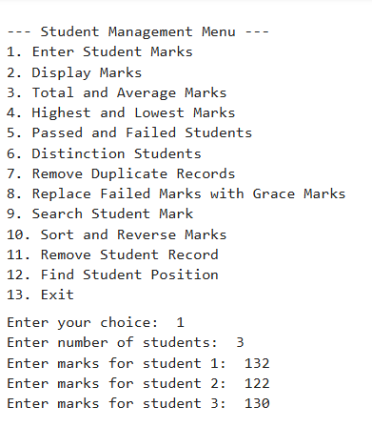1  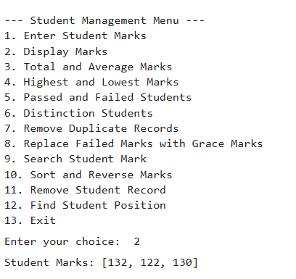  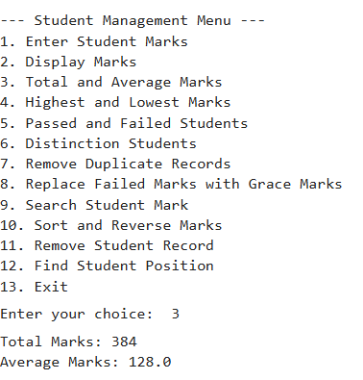  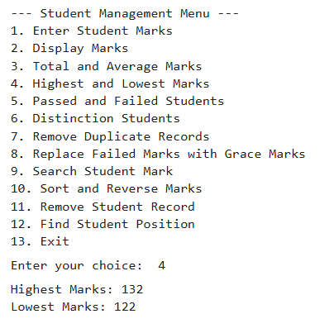  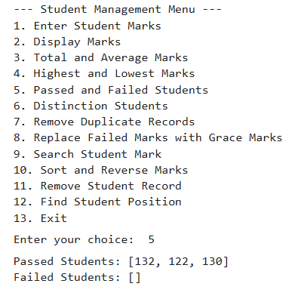  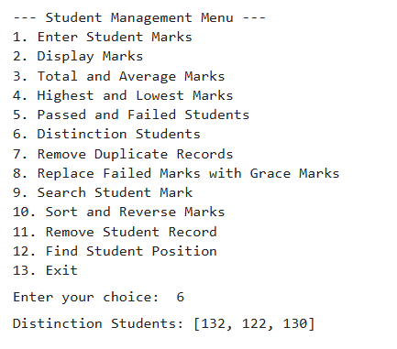  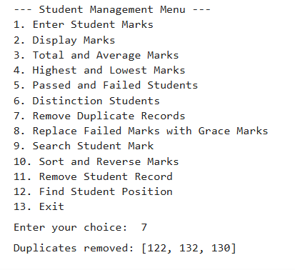  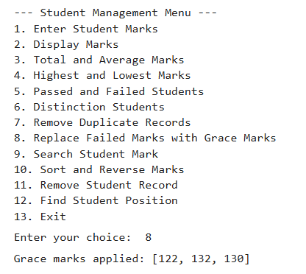  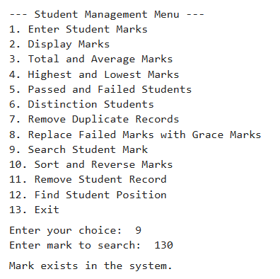  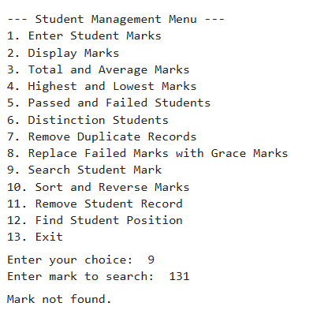  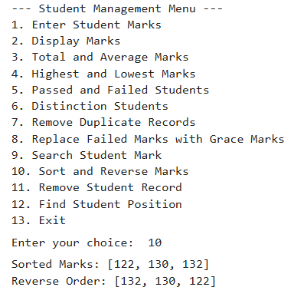  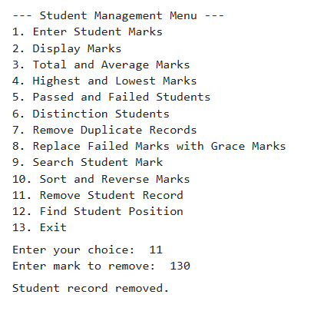  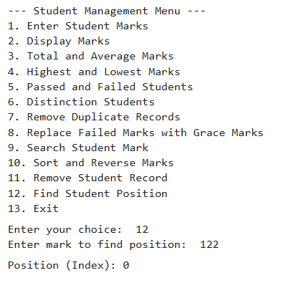  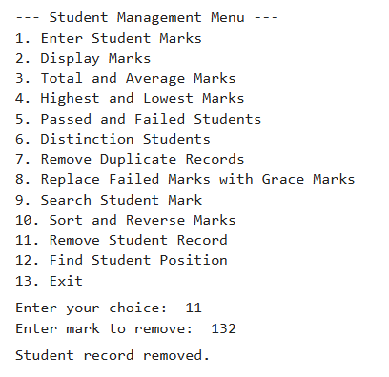  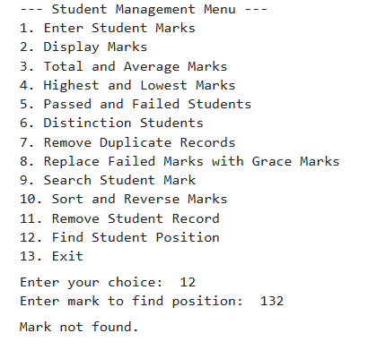  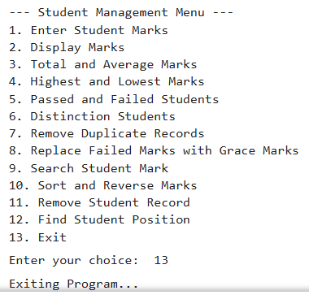
Debugging Questions with Corrected Answers
1 | Debug the following code  Wrong code:  lst = [1,2,3]  print(lst[3])
OP | Error: 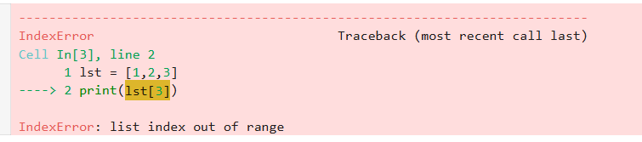  Correct code: 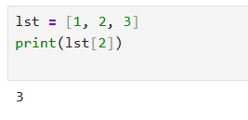
2 | Debug the following code  Wrong code:  lst = [10,20,30]  lst[1] =  print(lst)
OP | Error: 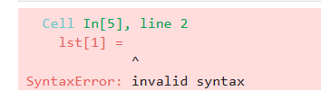  Correct code: 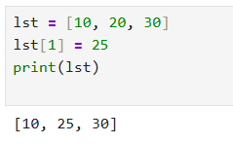
Conclusion | The error occurs because an assignment statement is incomplete.  In Python, when updating a list element, a value must be provided after the assignment operator (=).  Once a valid value is assigned to the specified index, the list updates correctly and prints the modified result.
Performance Indicators |  | Teachers Dated and Signature
Process Related  (15 M) | Product Related  (10 M) | Total (25 M)

